**CP Club 365 Days Challenge**

**Programming language – C++**

**Problem Statement**

<https://www.codechef.com/DSAPREP_01/problems/RAIN8TEST>

**Your Code**:

// 0x82Day of 0x365Days challenge

// VEDANT BHARAD

// 7-1-2023

#include <iostream>

using namespace std;

int main() {

    // your code goes here

    int t;

    cin>>t;

    while(t--){

        int n,x;

        cin>>n>>x;

        long long price=0;

        int rain[n];

        cin>>rain[0];

        if(rain[0]==1)

            price=price+x;

        for(int loop=1;loop<n;loop++){

            cin>>rain[loop];

            if(rain[loop-1]==1 || rain[loop]==1){

                price=price+x;

            }

        }

        cout<<price<<endl;

    }

    return 0;

}

**Output (Screen Shot)**:

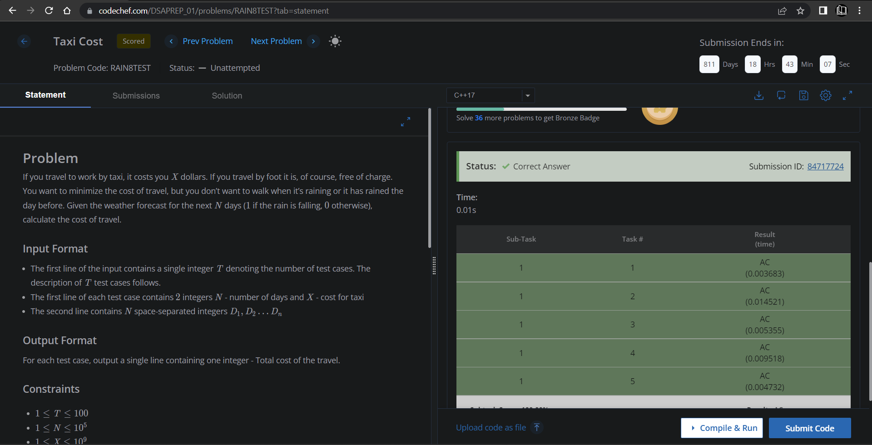

**Understanding about problem:**

* In this task I need to find price for Taxi if there is rain on that day or before that day then price will be added else for that day price is 0 and at last return sum of every day cost of travel.

Note: If you can't understand the problem, feel free to contact us and we'll help you. Please don't copy and paste from anywhere.

ALL THE BEST

Team CP Club